CSA1109- OBJECT ORIENTED ANALYSIS AND DESIGN
NAME:VARSHITHA.M
REGISTER NO:192520046

EXPERIMENT – 1-PASSPORT MANAGEMENT SYSTEM

1.USE CASE DIAGRAM

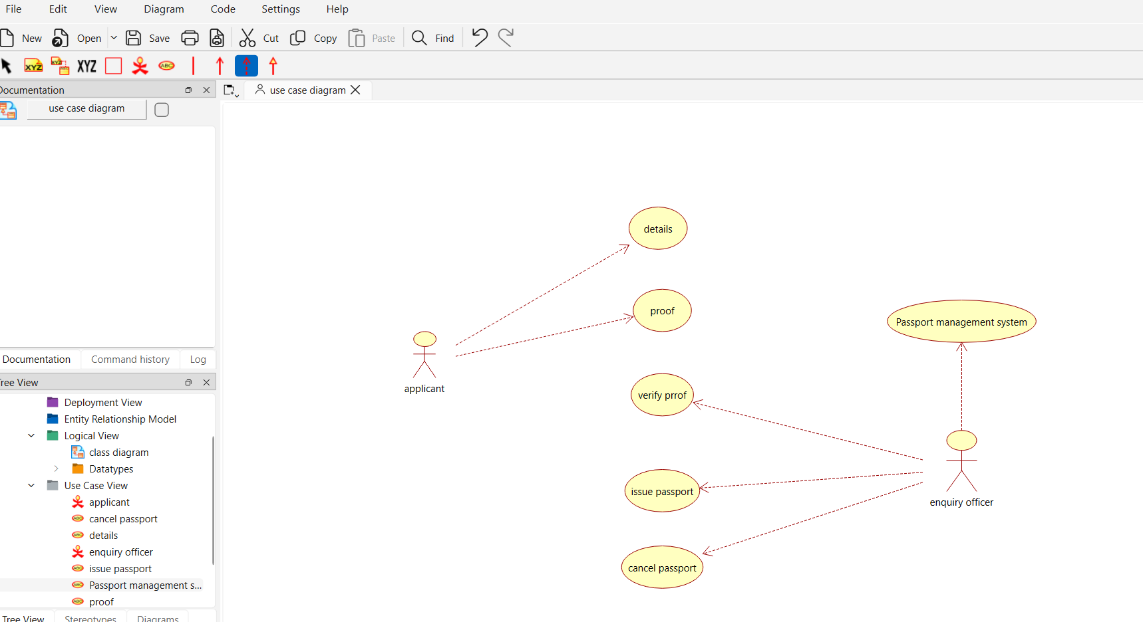

2.CLASS DIAGRAM

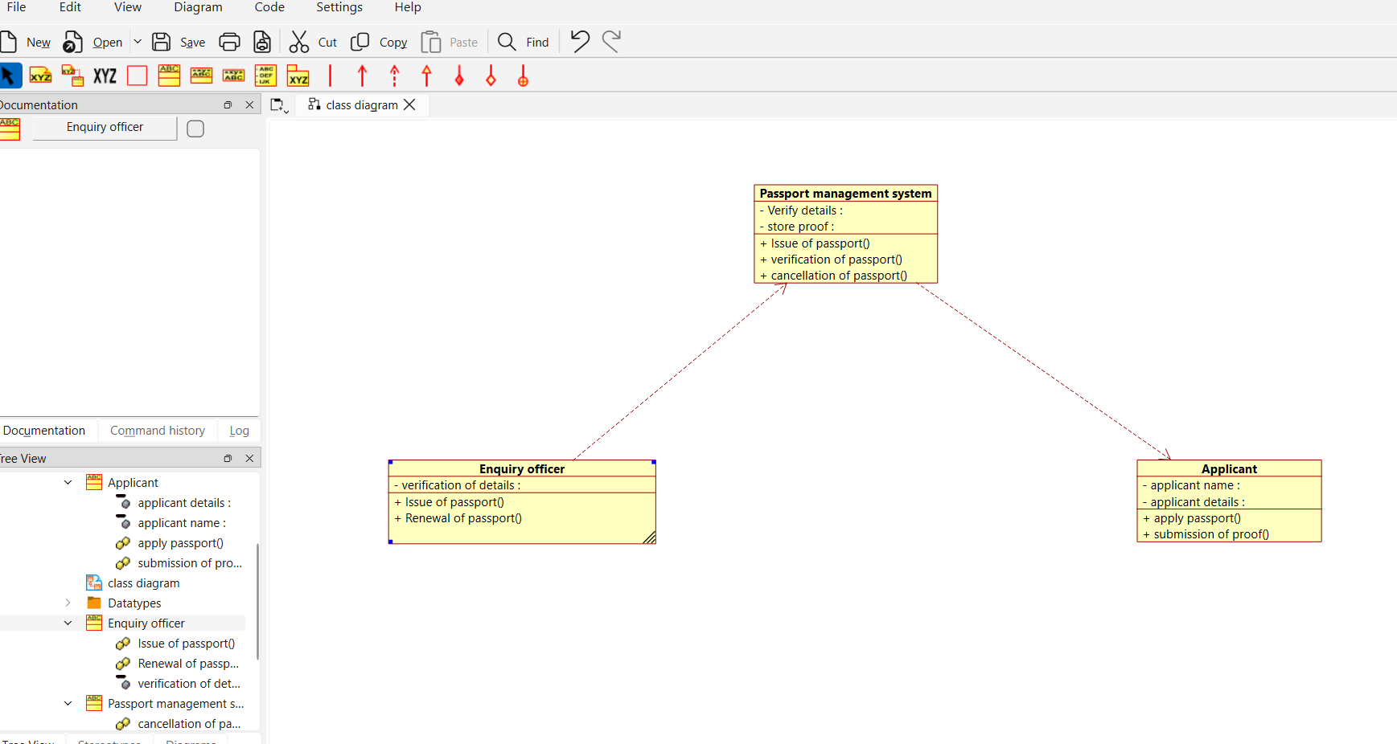

3.ACTIVITY DIAGRAM

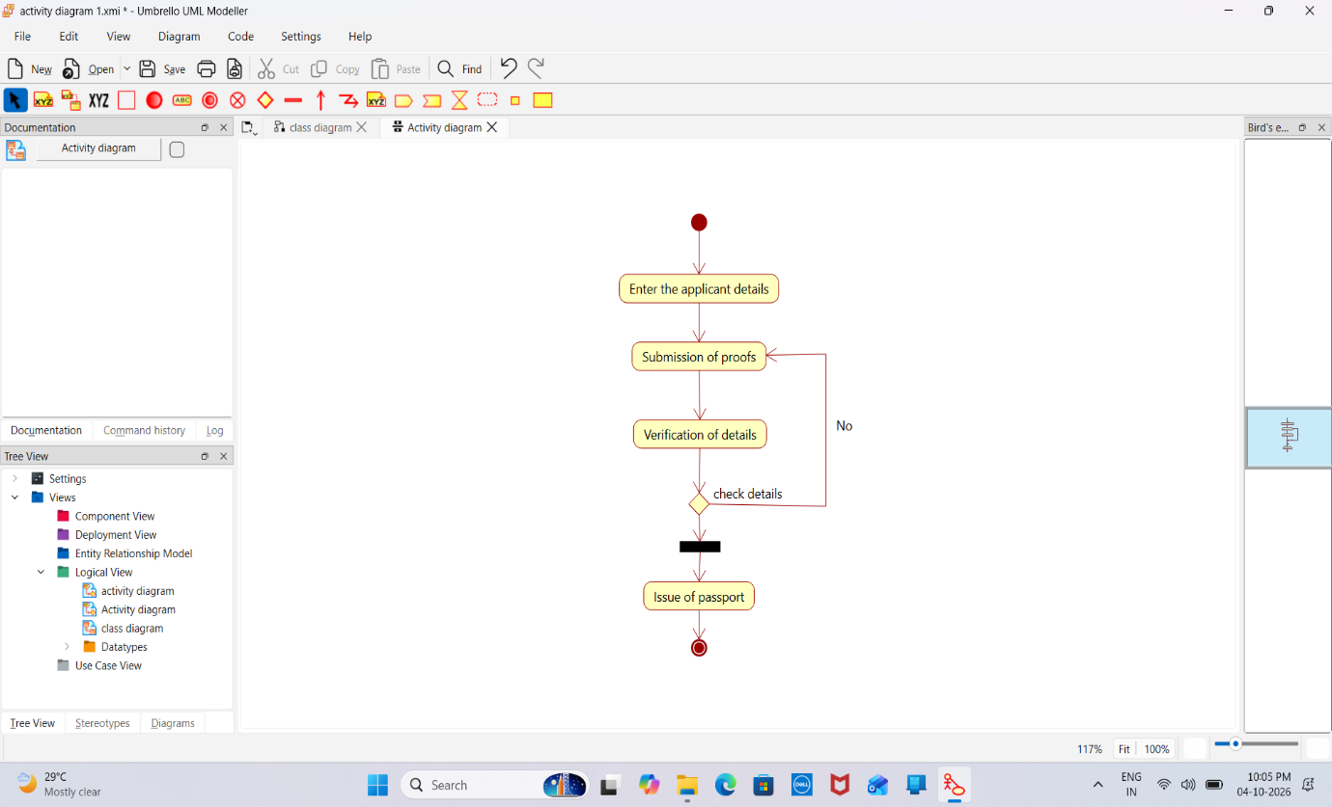

4.PACKAGE DIAGRAM

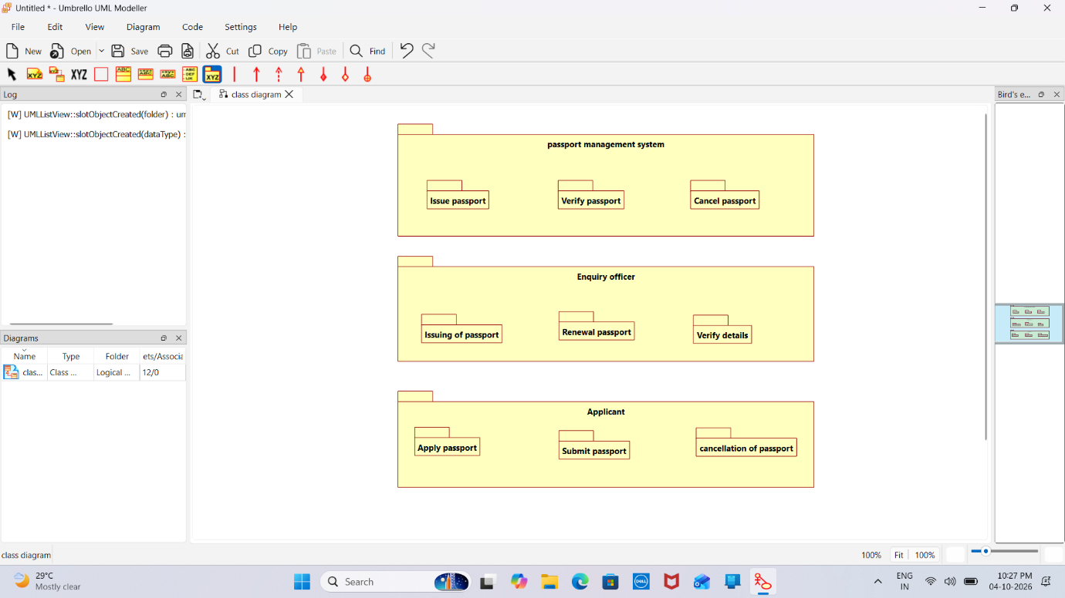
EXPERIMENT -2-BOOK BANK REGISTRATION SYSTEM
1.USE CASE DIAGRAM

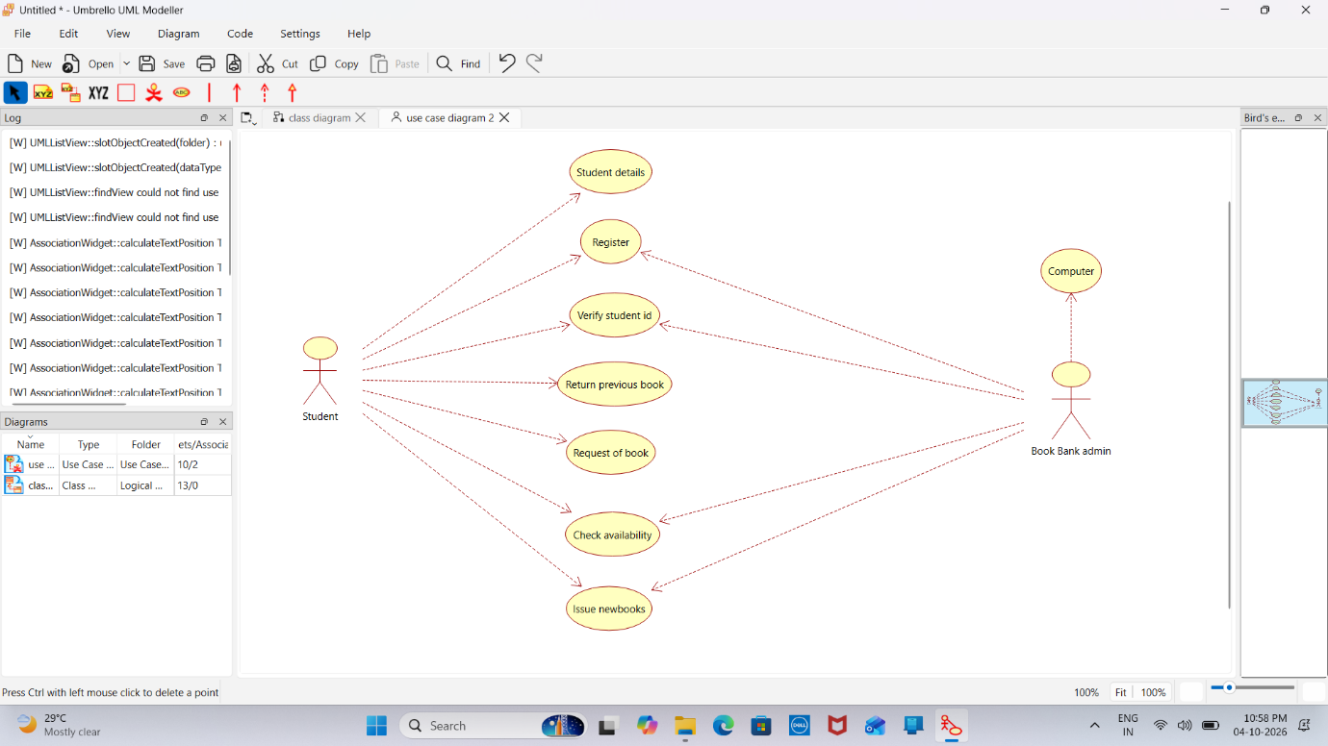

2.CLASS DIAGRAM

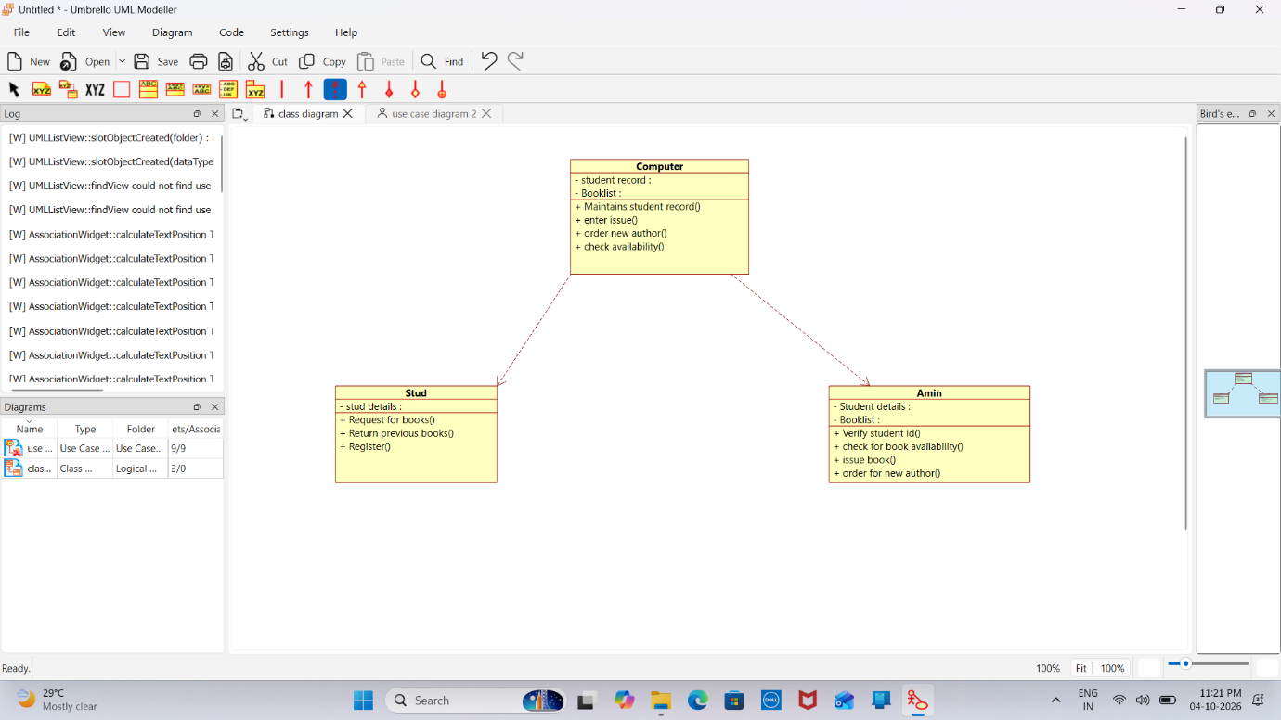
3.ACTIVITY DIAGRAM

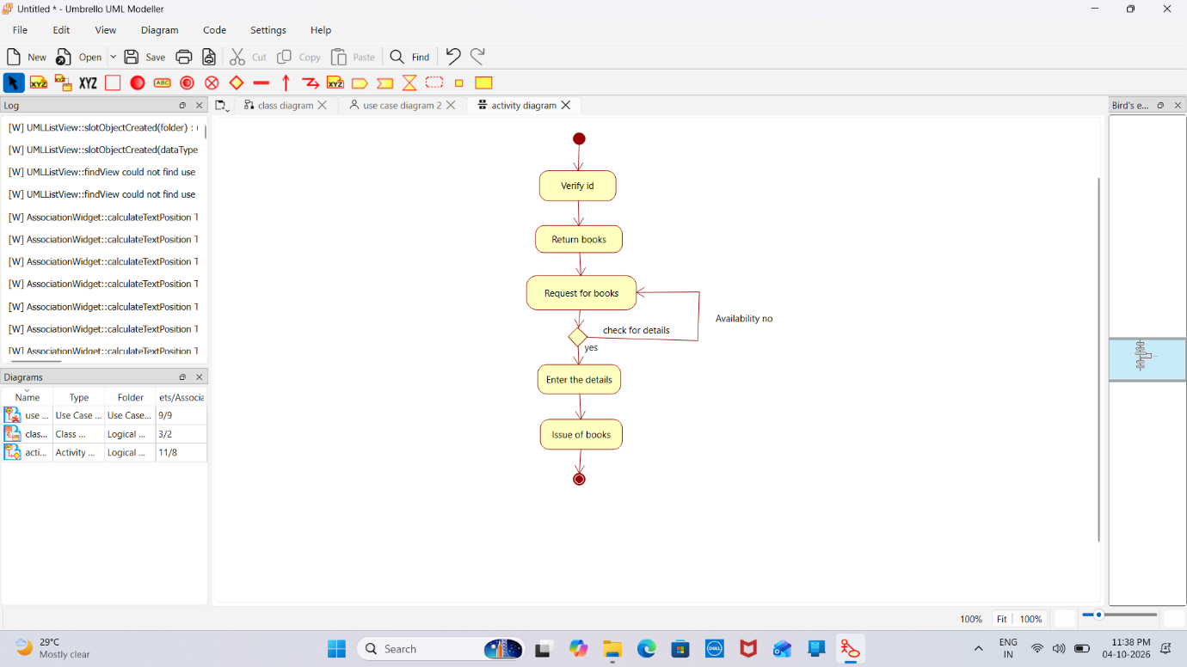

4.PACKAGE DIAGRAM

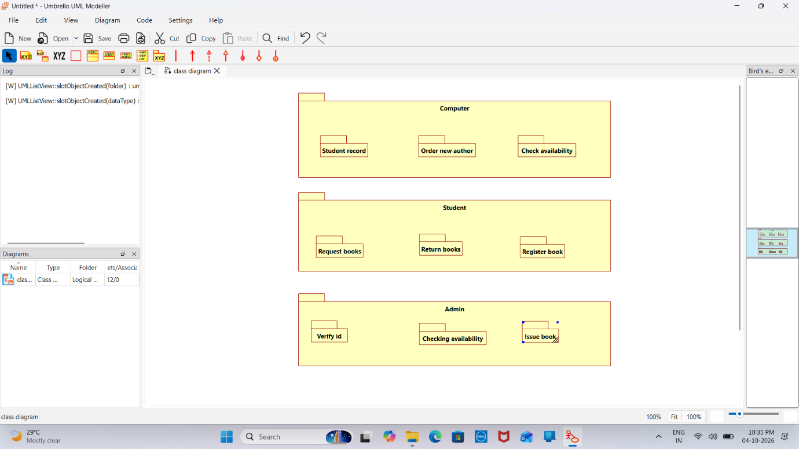

EXPERIMENT -3-EXAM REGISTRATION SYSTEM

- USE CASE DIAGRAM

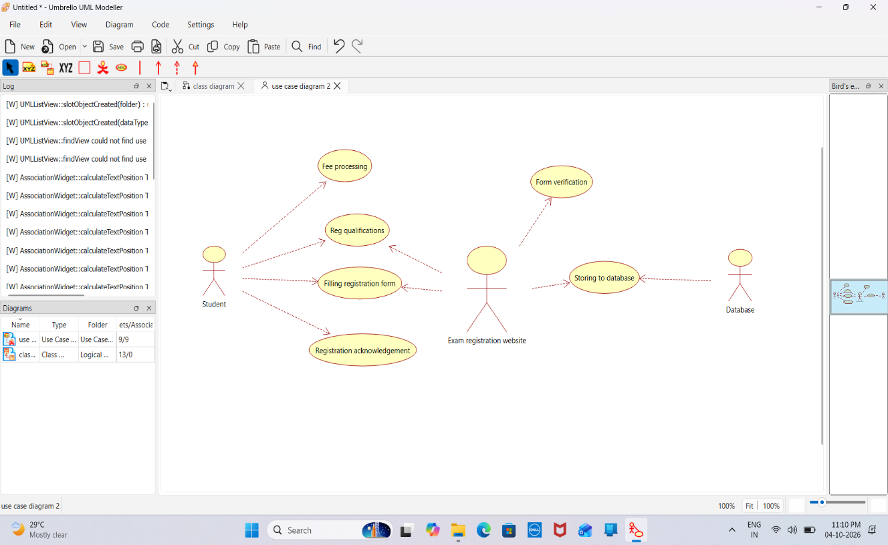

2.CLASS DIAGRAM

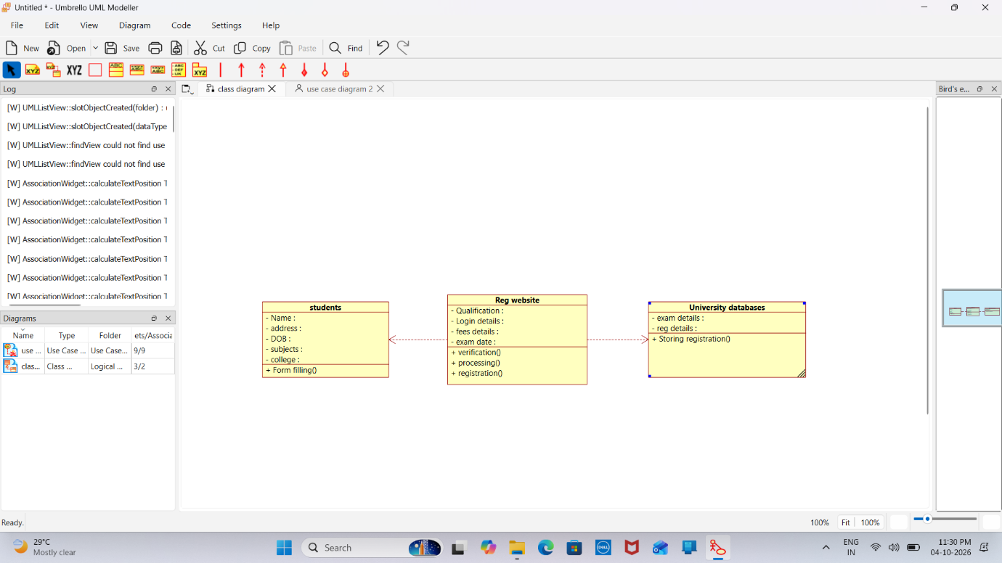
3.ACTIVITY DIAGRAM

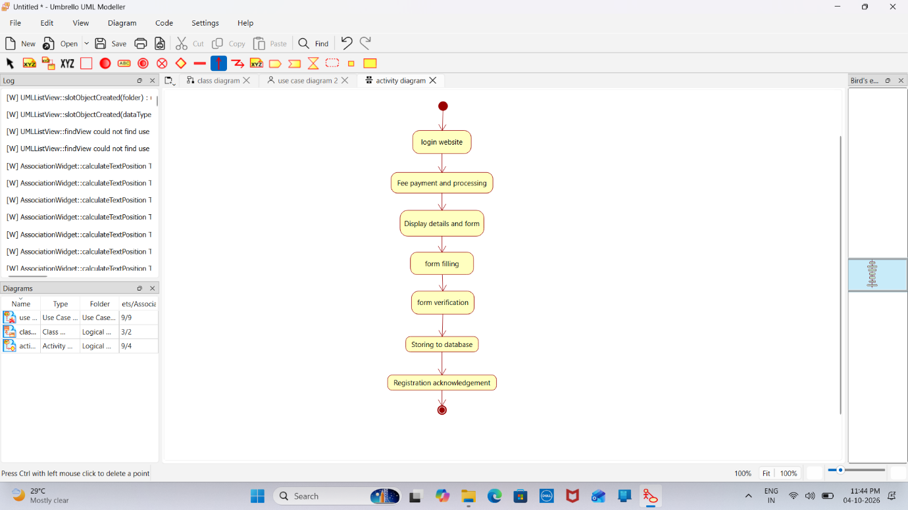

4.PACKAGE DIAGRAM

